Parking Lot Circuit Pricing

# Common

| Part | Price |
| --- | --- |
| ESP32 | ~$15 |
| [Power adapter (5V)](https://www.mouser.ca/ProductDetail/MEAN-WELL/RS-15-5?qs=hPu8TEI4q5cBcSse2JHxJA%3D%3D&mgh=1&gad_source=1&gclid=CjwKCAiA-bmsBhAGEiwAoaQNmu_s3QHDTXMK72ByjqZi0UNAf0Y40i6hFXNdAO3kXCn0jakoMrS8JhoCeLsQAvD_BwE) | ~$10 |
| ESP32-CAM x 2 | ~$40 |
| [Zip-ties (black)](https://www.cabletiesandmore.ca/black-zip-ties-uv) (100 pcs) | ~$0.85 |
| Total | ~$65 |

# LED Circuit

| Part | Price |
| --- | --- |
| [Resistor (100 Ohm)](https://www.digikey.ca/en/products/detail/yageo/RC0402FR-07100RL/726527) | $0.15 |
| [SN74HC04DR (Hex inverter)](https://www.digikey.ca/en/products/detail/texas-instruments/SN74HC04DR/276832) x 2 | $0.61 |
| [LED (Green)](https://www.digikey.ca/en/products/detail/w%C3%BCrth-elektronik/151031VS06000/4489988) x 8 | $0.26 |
| [LED (Red)](https://www.digikey.ca/en/products/detail/w%C3%BCrth-elektronik/151033RS03000/4490003) x 8 | $0.28 |
| Total | ~$7 |

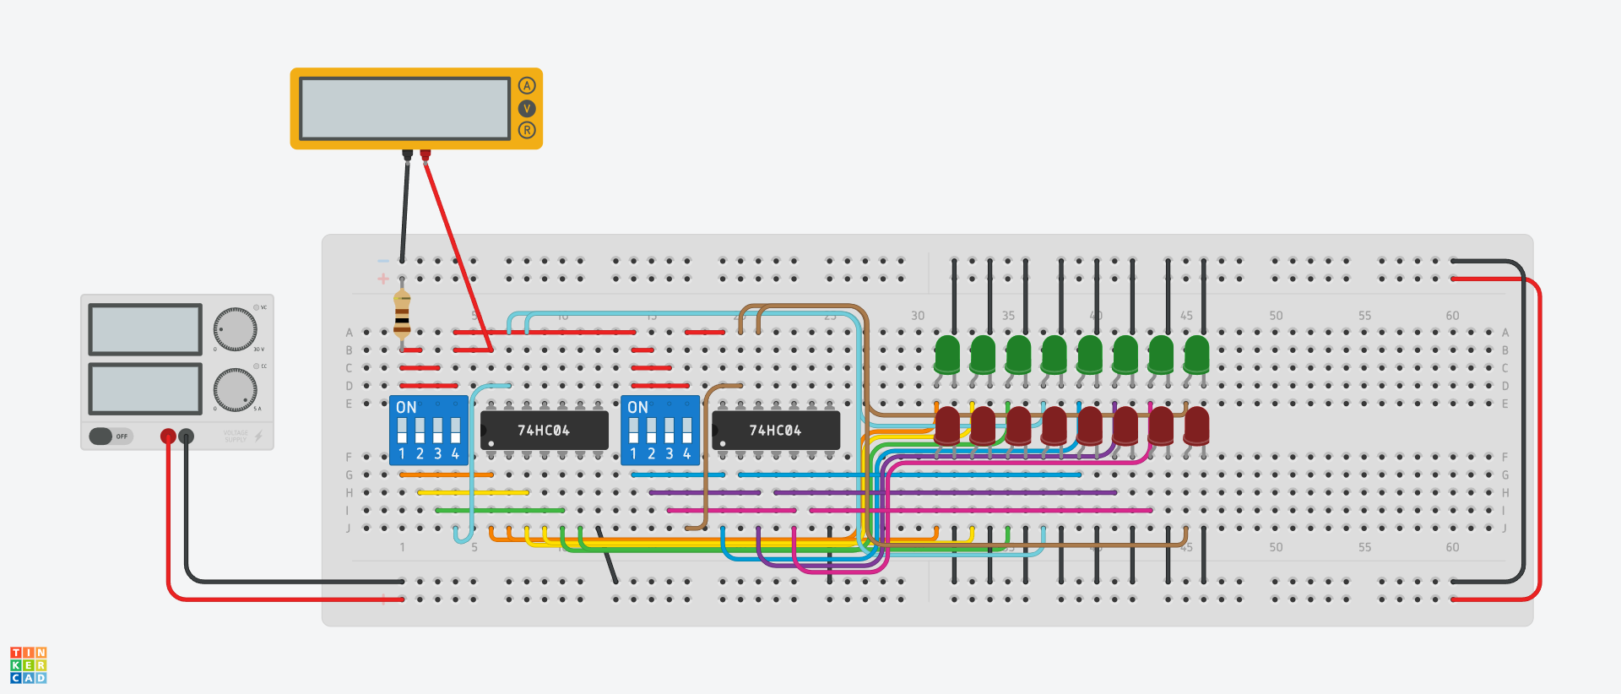

# Sensor Circuit

| Part | Price |
| --- | --- |
| [FSR402](https://www.aliexpress.com/item/1005003890372970.html?spm=a2g0o.cart.0.0.202b38da0y9rPi&mp=1) x 8 | $1.93 |
| Resistor (1kOhm) x 8 | $0.20 |
| Total | ~$20 |

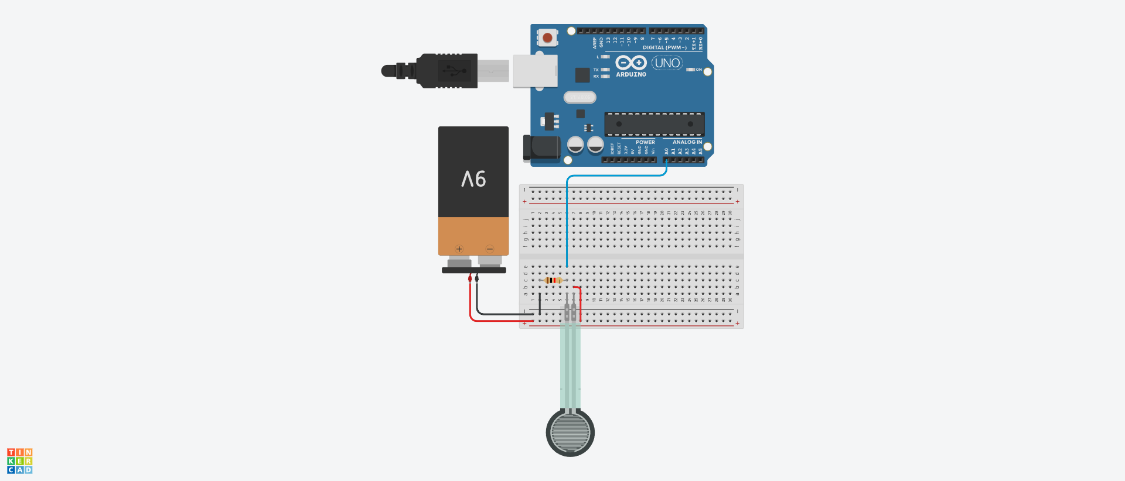

**Grand Total ~= 100**